# **App Dev Coursework Templates**

## **1. Template:**

[Butterfly Bootstrap Template Demo (bootstrapmade.com)](https://bootstrapmade.com/demo/Butterfly/)

## **2. Template:**

## [Material Kit: Free Bootstrap 5 Material Design UI Kit @ Creative Tim (creative-tim.com)](https://www.creative-tim.com/product/material-kit)

## **3. Template:**

## [Tmart - Free Minimal eCommerce HTML5 Template - ThemeHunt](https://themehunt.com/item/1527068-tmart-free-minimal-ecommerce-html5-template)

## **4. Template:**

[Superb - Responsive Ecommerce Template - ThemeHunt](https://themehunt.com/item/1525767-superb-responsive-ecommerce-template)

## **5. Template:**

## [Nature Look & Speed - 2 Multipurpose Responsive Ecommerce HTML Template - ThemeHunt](https://themehunt.com/item/1526723-nature-look-speed-2-multipurpose-responsive-ecommerce-html-template) **6. Template:**

[Digitf - Furniture Website Template (html.design)](https://html.design/download/digitf-furniture-website-template/)

## **7. Template:**

[Ogani - Free Bootstrap 4 HTML5 Responsive Ecommerce Website Template (themewagon.com)](https://themewagon.com/themes/free-bootstrap-4-html5-responsive-ecommerce-website-template-ogani/)

## **8. Template:**

[MaleFashion - Free Bootstrap 4 HTML5 eCommerce Website Template - ThemeWagon](https://themewagon.com/themes/free-bootstrap-4-html5-ecommerce-website-template-malefashion/)

## **9. Template:**

[Aranoz - Free Bootstrap 4 HTML5 Ecommerce Website Template (themewagon.com)](https://themewagon.com/themes/free-bootstrap-4-html5-ecommerce-website-template-aranoz/)

## **10. Template:**

[Violet - Free Bootstrap 4 HTML5 Responsive Ecommerce Website Template (themewagon.com)](https://themewagon.com/themes/free-bootstrap-4-html5-responsive-ecommerce-website-template-violet/)

## **11. Template:**

[Amado - Free Multipage e-commerce Template (themewagon.com)](https://themewagon.com/themes/free-html5-e-commerce-template-bootstrap4-amado/)

## **12. Template:**

[Shionhouse - Free Responsive Bootstrap 4 HTML5 eCommerce Website Template (themewagon.com)](https://themewagon.com/themes/free-responsive-bootstrap-4-html5-ecommerce-website-template-shionhouse/)

## **13. Template:**

[Aviato E-commerce Template - Themefisher](https://themefisher.com/products/aviato-e-commerce-template/)

## **14. Template:**

[Cozastore - Free HTML5 eCommerce Website Template - ThemeWagon](https://themewagon.com/themes/free-html5-ecommerce-website-template/)

## **15. Template:**

[Theplaza Bootstrap 4 HTML5 Responsive Ecommerce Website Template (themewagon.com)](https://themewagon.com/themes/free-bootstrap-4-html5-responsive-ecommerce-website-template-theplaza/)

## **16. Template:**

[Pillow Mart - Free Bootstrap 4 HTML5 Responsive Online Store Template - ThemeWagon](https://themewagon.com/themes/free-bootstrap-4-html5-responsive-online-store-template-pillow-mart/)

## **17. Template:**

[Fashi - Free Bootstrap 4 HTML5 eCommerce Website Template (themewagon.com)](https://themewagon.com/themes/free-bootstrap-4-html5-ecommerce-website-template-fashi/)

## **18. Template:**

[Karma - Free Reponsive Bootstrap 4 HTML5 eCommerce Website Template (themewagon.com)](https://themewagon.com/themes/free-reponsive-bootstrap-4-html5-ecommerce-website-template-karma/)

## **19. Template:**

[Estore - Free Bootstrap 4 HTML5 eCommerce Website Template (themewagon.com)](https://themewagon.com/themes/free-bootstrap-4-html5-ecommerce-website-templateestore/)

## **My top picks:**

Number 14 - [Cozastore - Free HTML5 eCommerce Website Template - ThemeWagon](https://themewagon.com/themes/free-html5-ecommerce-website-template/)

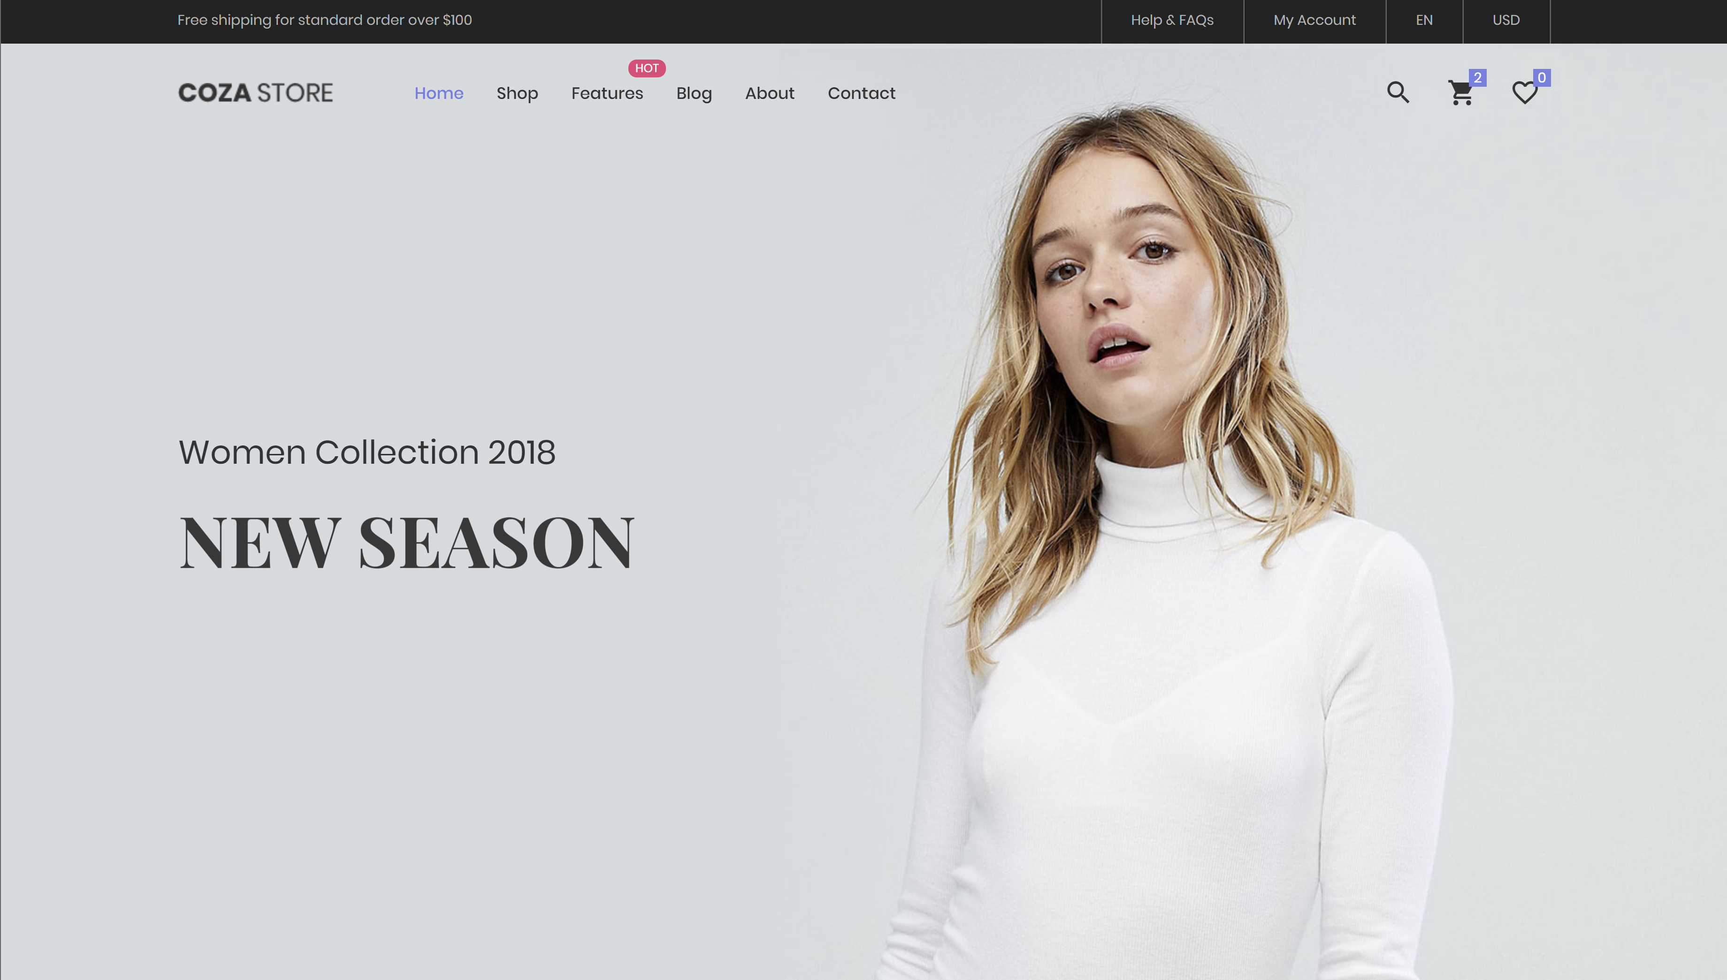

Figure 1: Coza Store Home Page

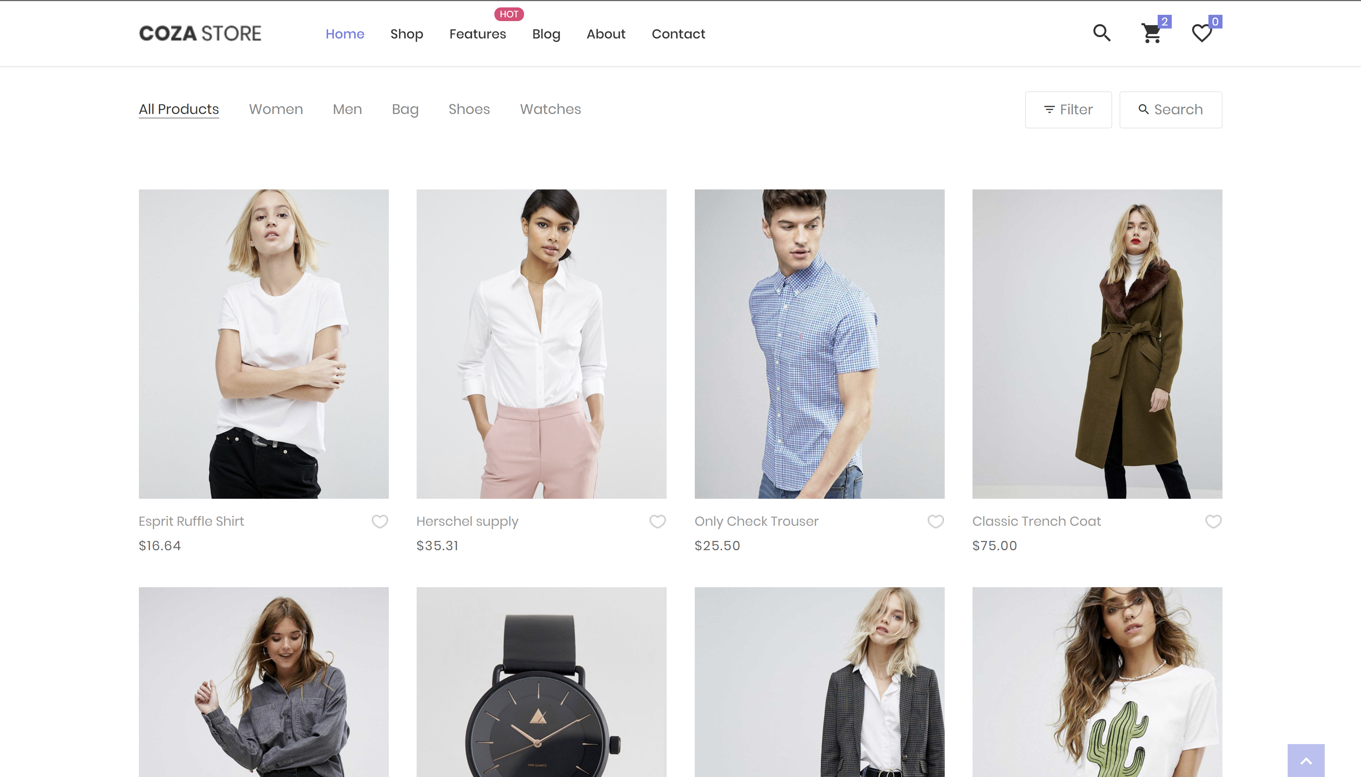

Figure 2: Coza Store Shop Page

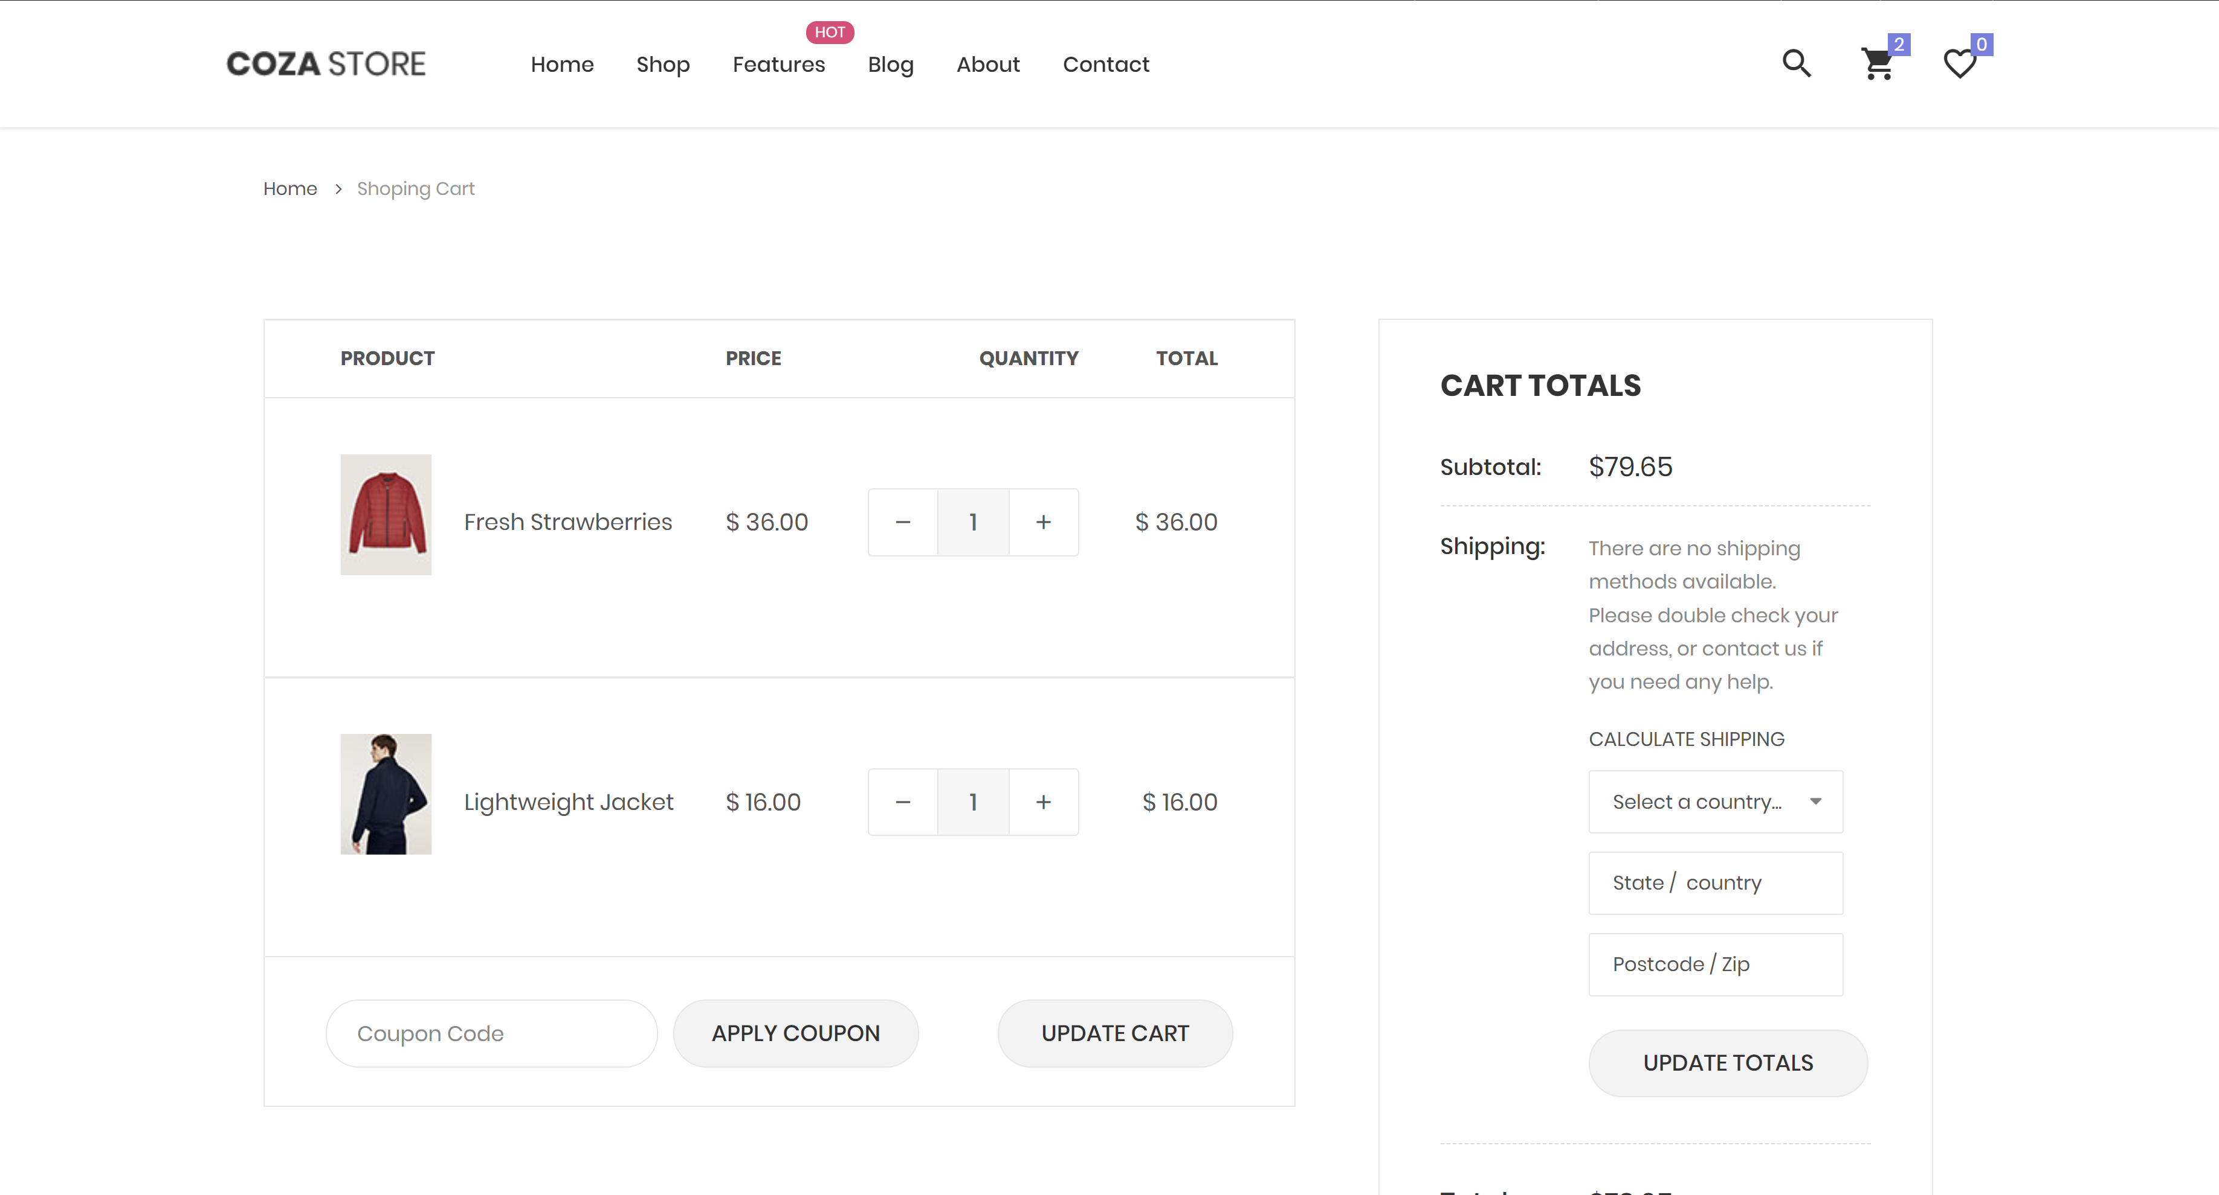

Figure 3: Coza Store Cart Page

Features:

* Multi-page Template
* Sticky Navigation
* Full-width Search Bar
* Multi-level Dropdown
* Carousel Slider
* Advanced Course Search
* On-hover Animation
* Pagination On Blog
* Social Media Icons
* Right Sidebar
* Google Maps Available
* Descriptive Footer
* Back To Top Button

Number 9 - [Aranoz - Free Bootstrap 4 HTML5 Ecommerce Website Template (themewagon.com)](https://themewagon.com/themes/free-bootstrap-4-html5-ecommerce-website-template-aranoz/)

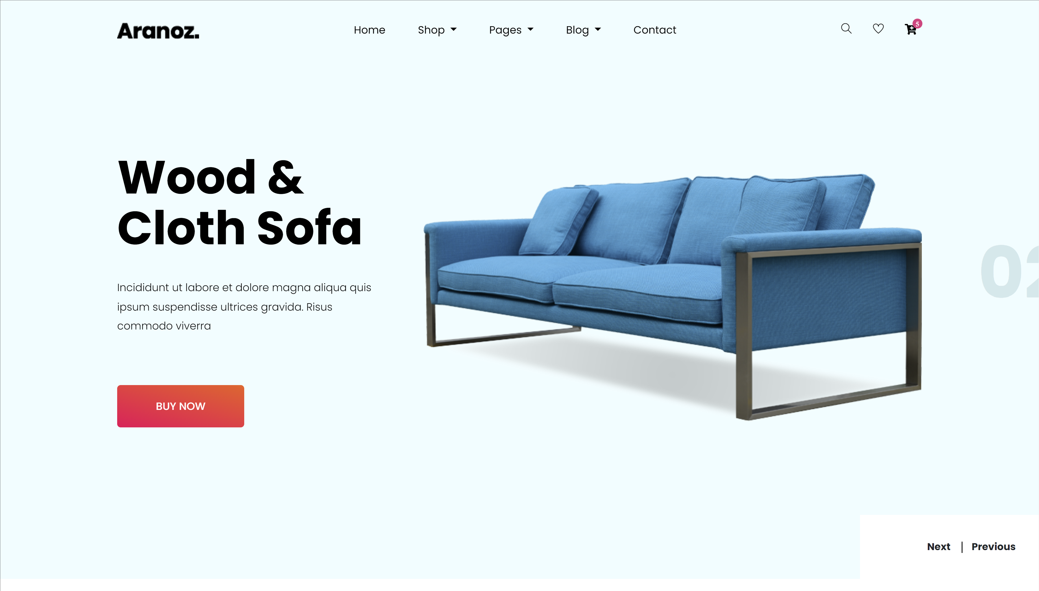

Figure 4: Aranoz Home Page

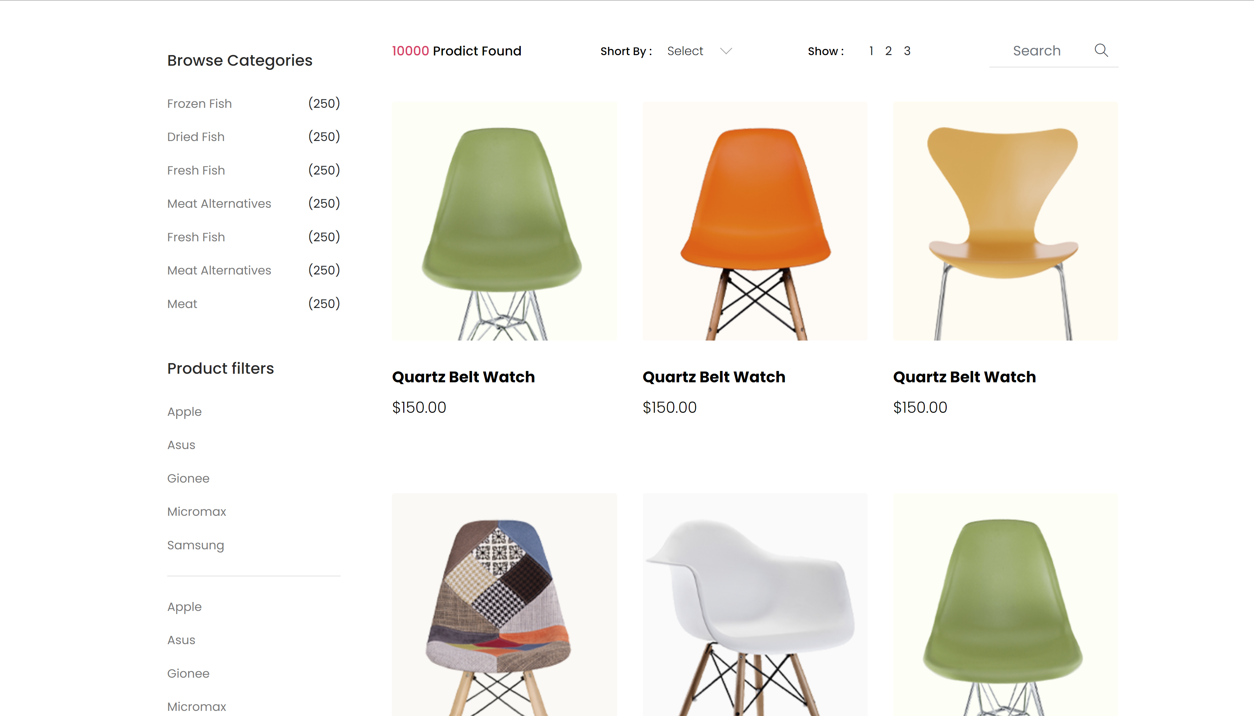

Figure 5: Aranoz Shop By Category Page

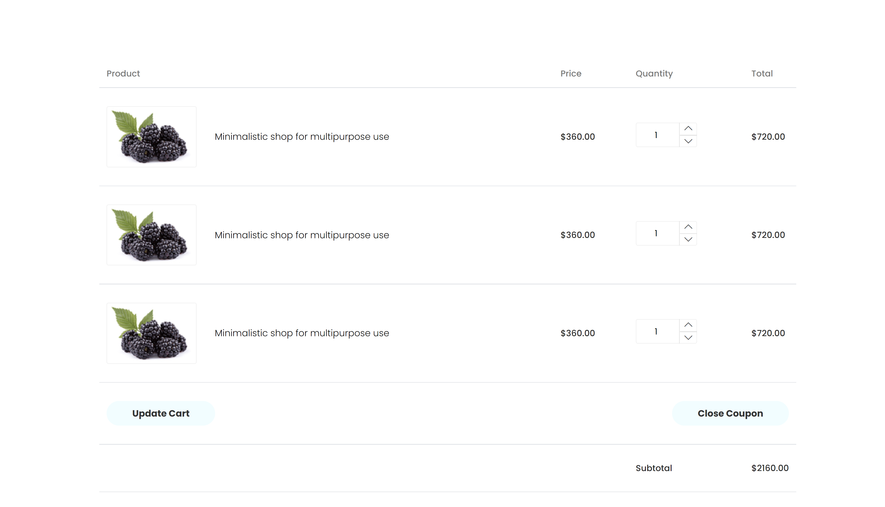

Figure 6: Aranoz Shopping Cart Page

Features:

* Clean and minimal design
* Cross-browser compatibility
* Fully responsive
* Multi-page template
* Hero header
* Drop-down menu
* Off-canvas search box
* Call to action button
* Slider on the header
* On hover effect on images
* Product carousel
* Countdown timers
* Footer navigations
* Breadcrumbs
* Pagination UI
* Price ranger
* Product grid with filters
* Tabbed content
* Review form UI
* Comment form UI
* Newsletter subscription form
* Login form UI
* Tracking form UI
* Checkout page
* 10+ UI elements
* Shopping cart

Number 8 - [MaleFashion - Free Bootstrap 4 HTML5 eCommerce Website Template - ThemeWagon](https://themewagon.com/themes/free-bootstrap-4-html5-ecommerce-website-template-malefashion/)

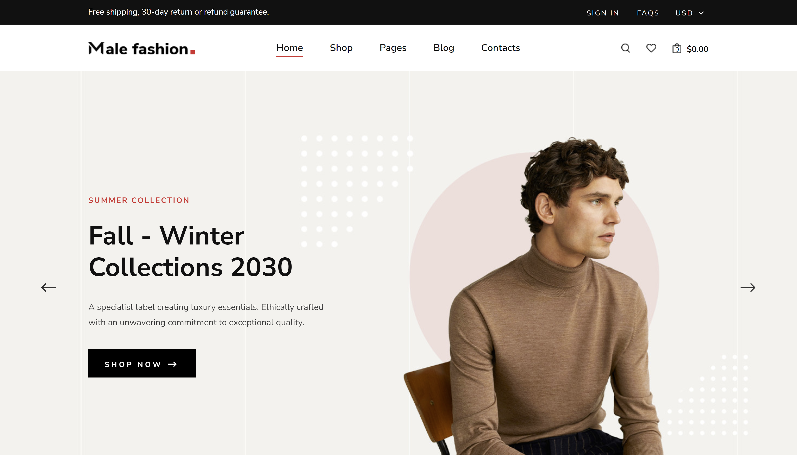

Figure 7: MaleFashion Home Page

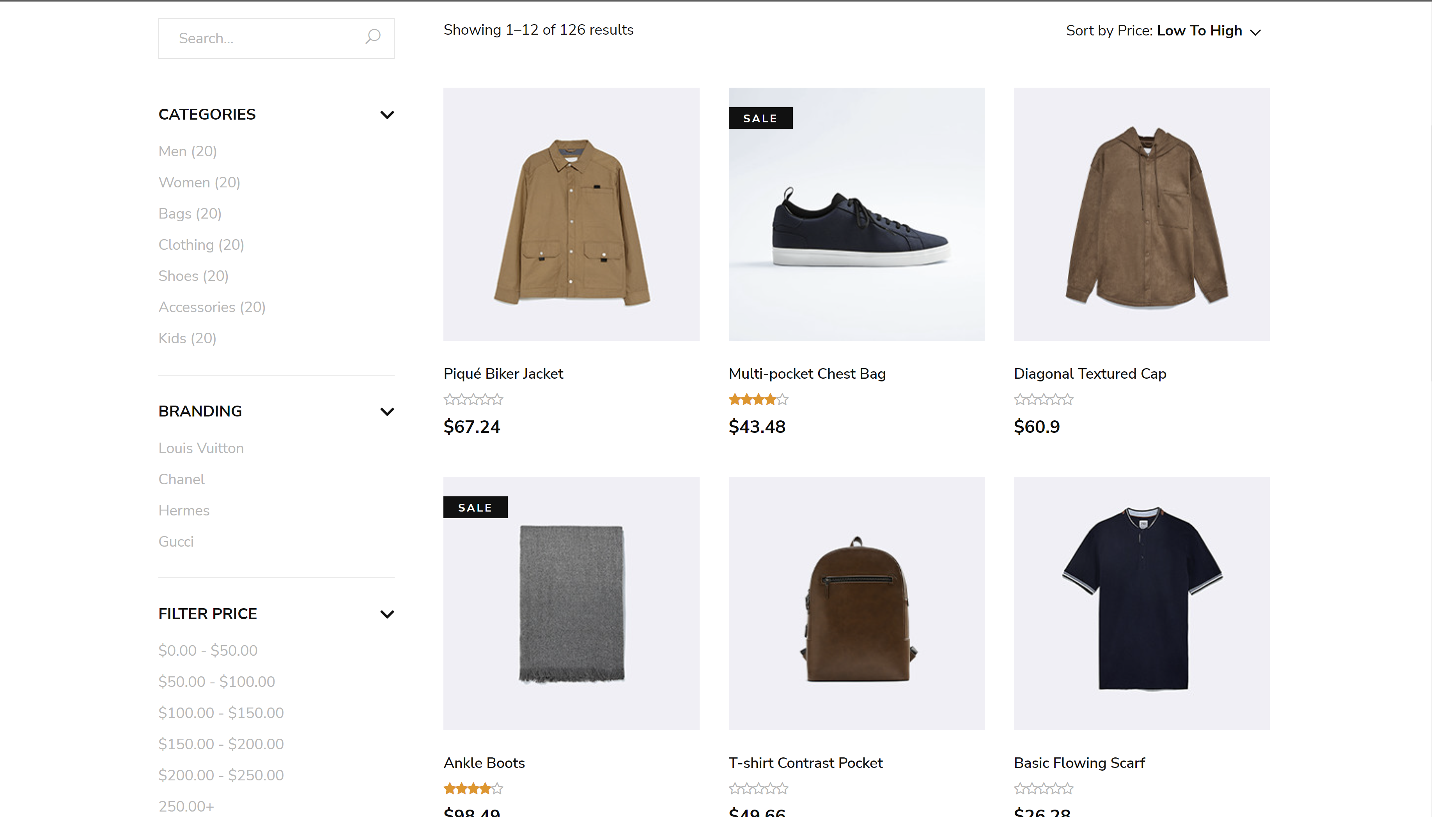

Figure 8: MaleFashion Shop Page

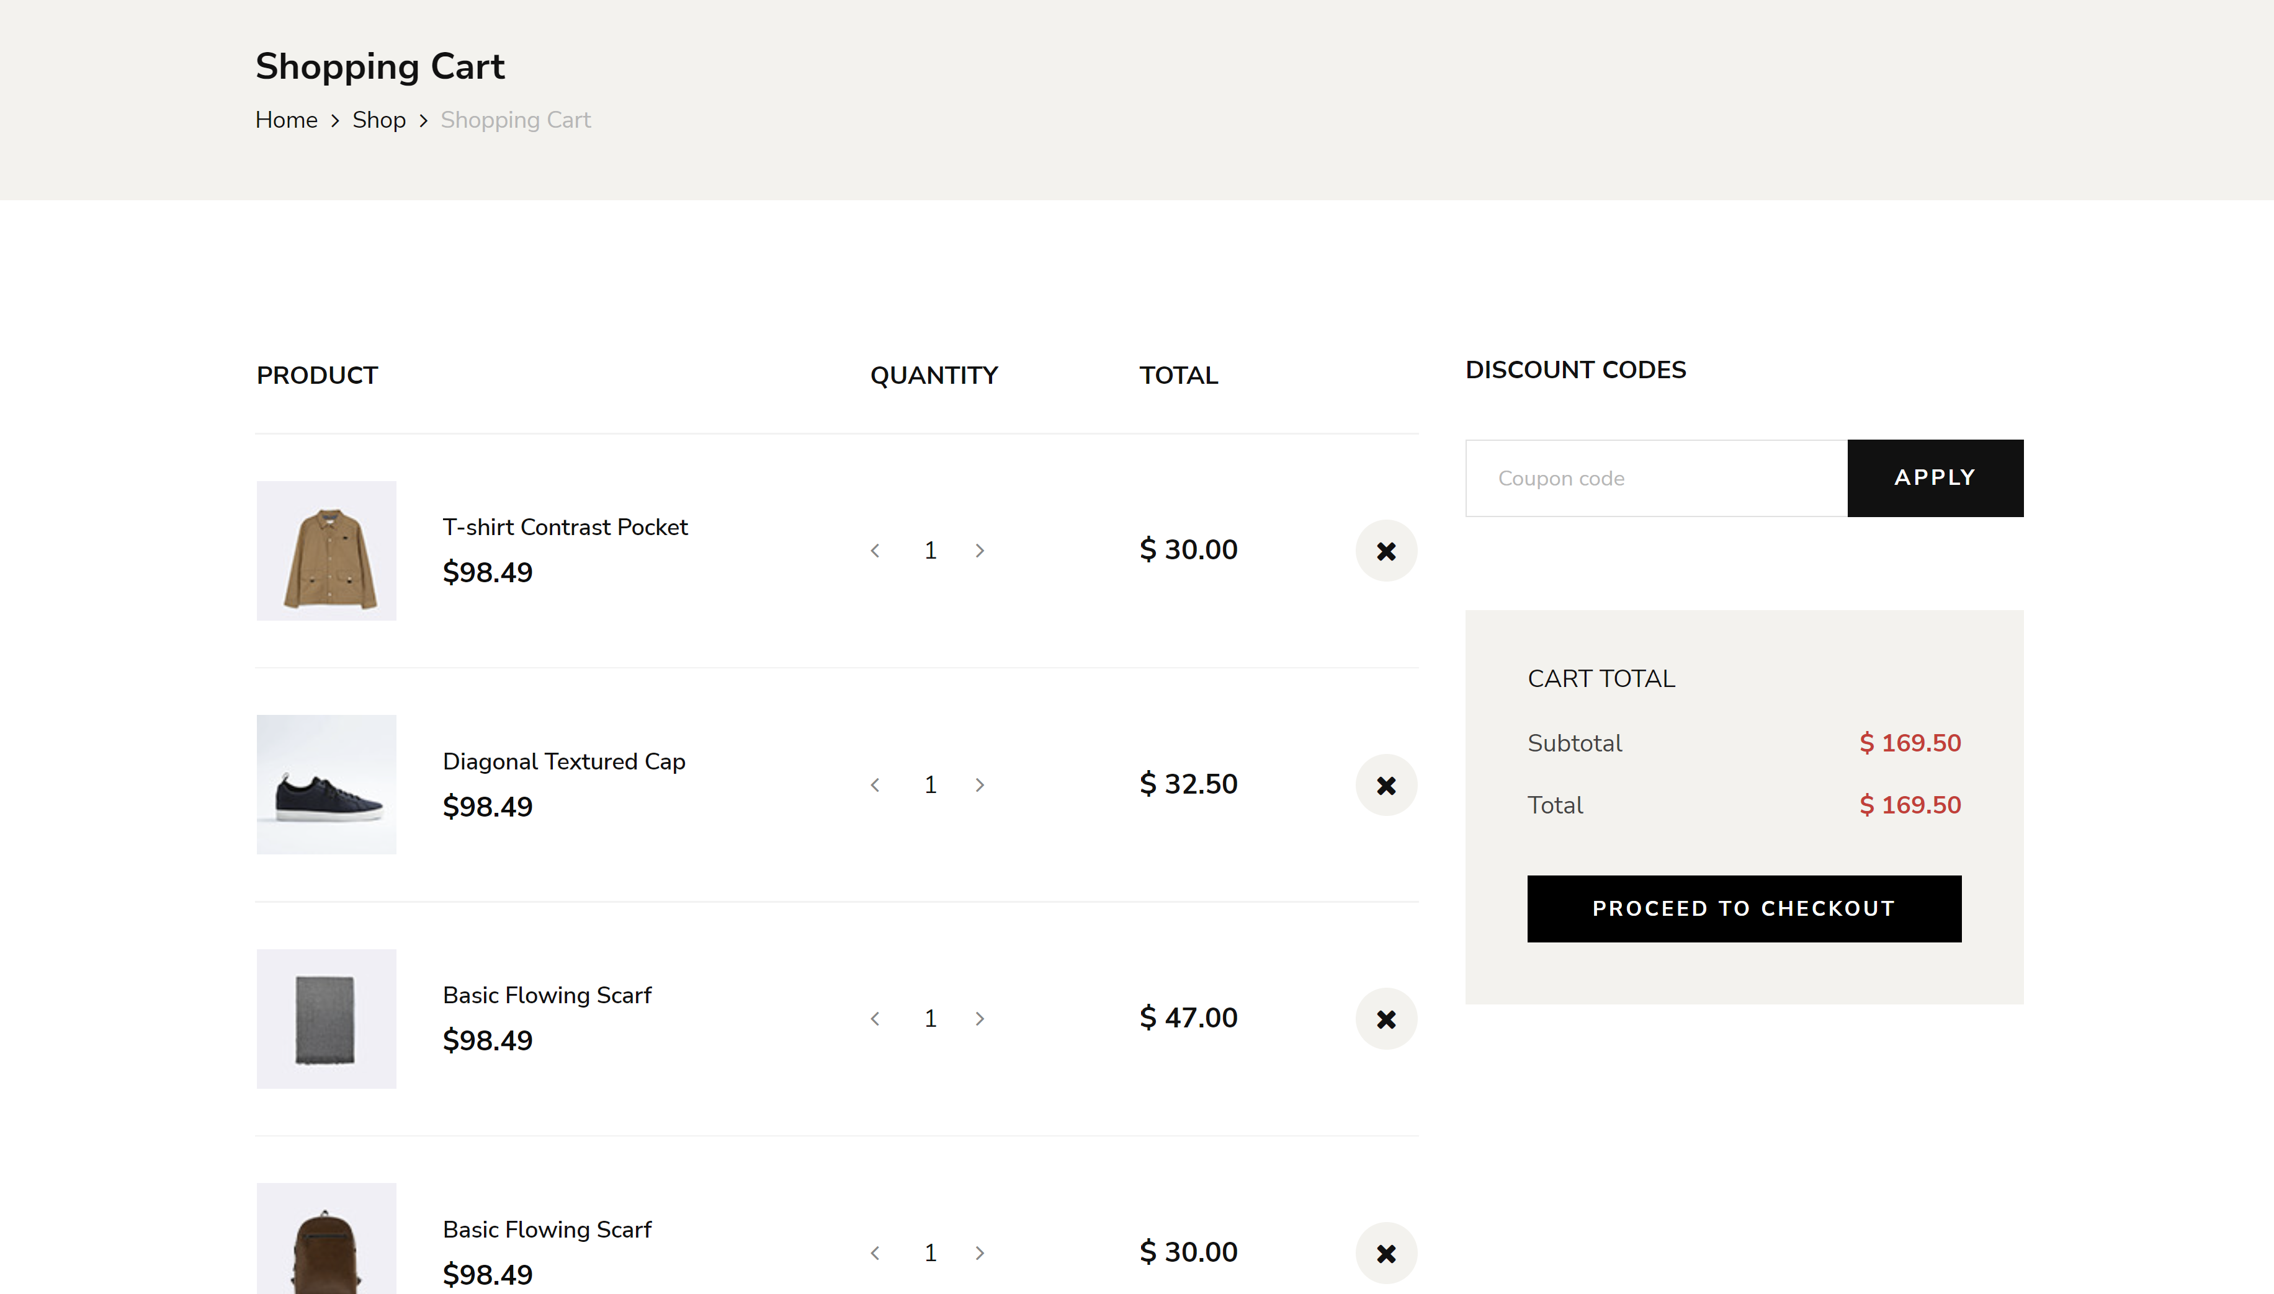

Figure 9: MaleFashion Shopping Cart Page

Features:

* Cross-browser compatibility
* Multi-page template
* Clean & dynamic design
* Fully responsive
* Hero header with slider
* Drop-down menu
* Countdown timer
* Blog section
* Newsletter subscription form
* Sorted product grid
* Call to action button
* Breadcrumbs
* Search option
* Fun fact counters
* Product detail pages
* Modal image view
* Shopping cart
* Checkout pages
* Comment form UI
* Contact form
* Footer navigation

Number 17 - [Fashi - Free Bootstrap 4 HTML5 eCommerce Website Template (themewagon.com)](https://themewagon.com/themes/free-bootstrap-4-html5-ecommerce-website-template-fashi/)

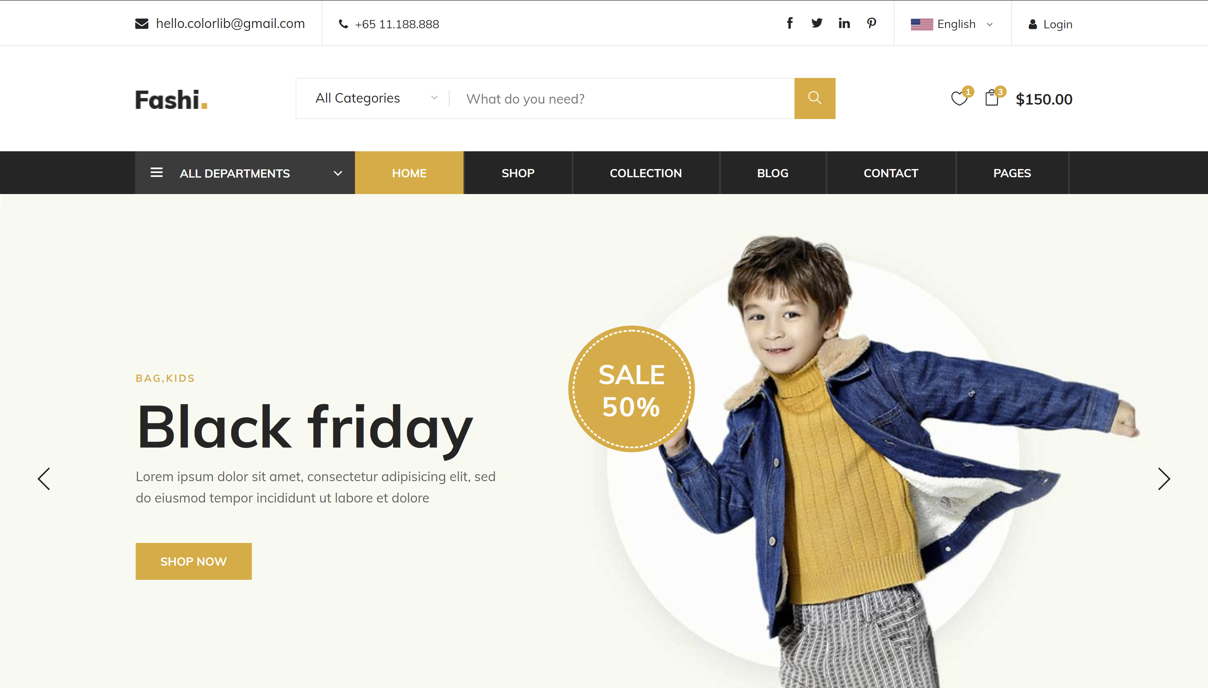

Figure 10: Fashi HomePage

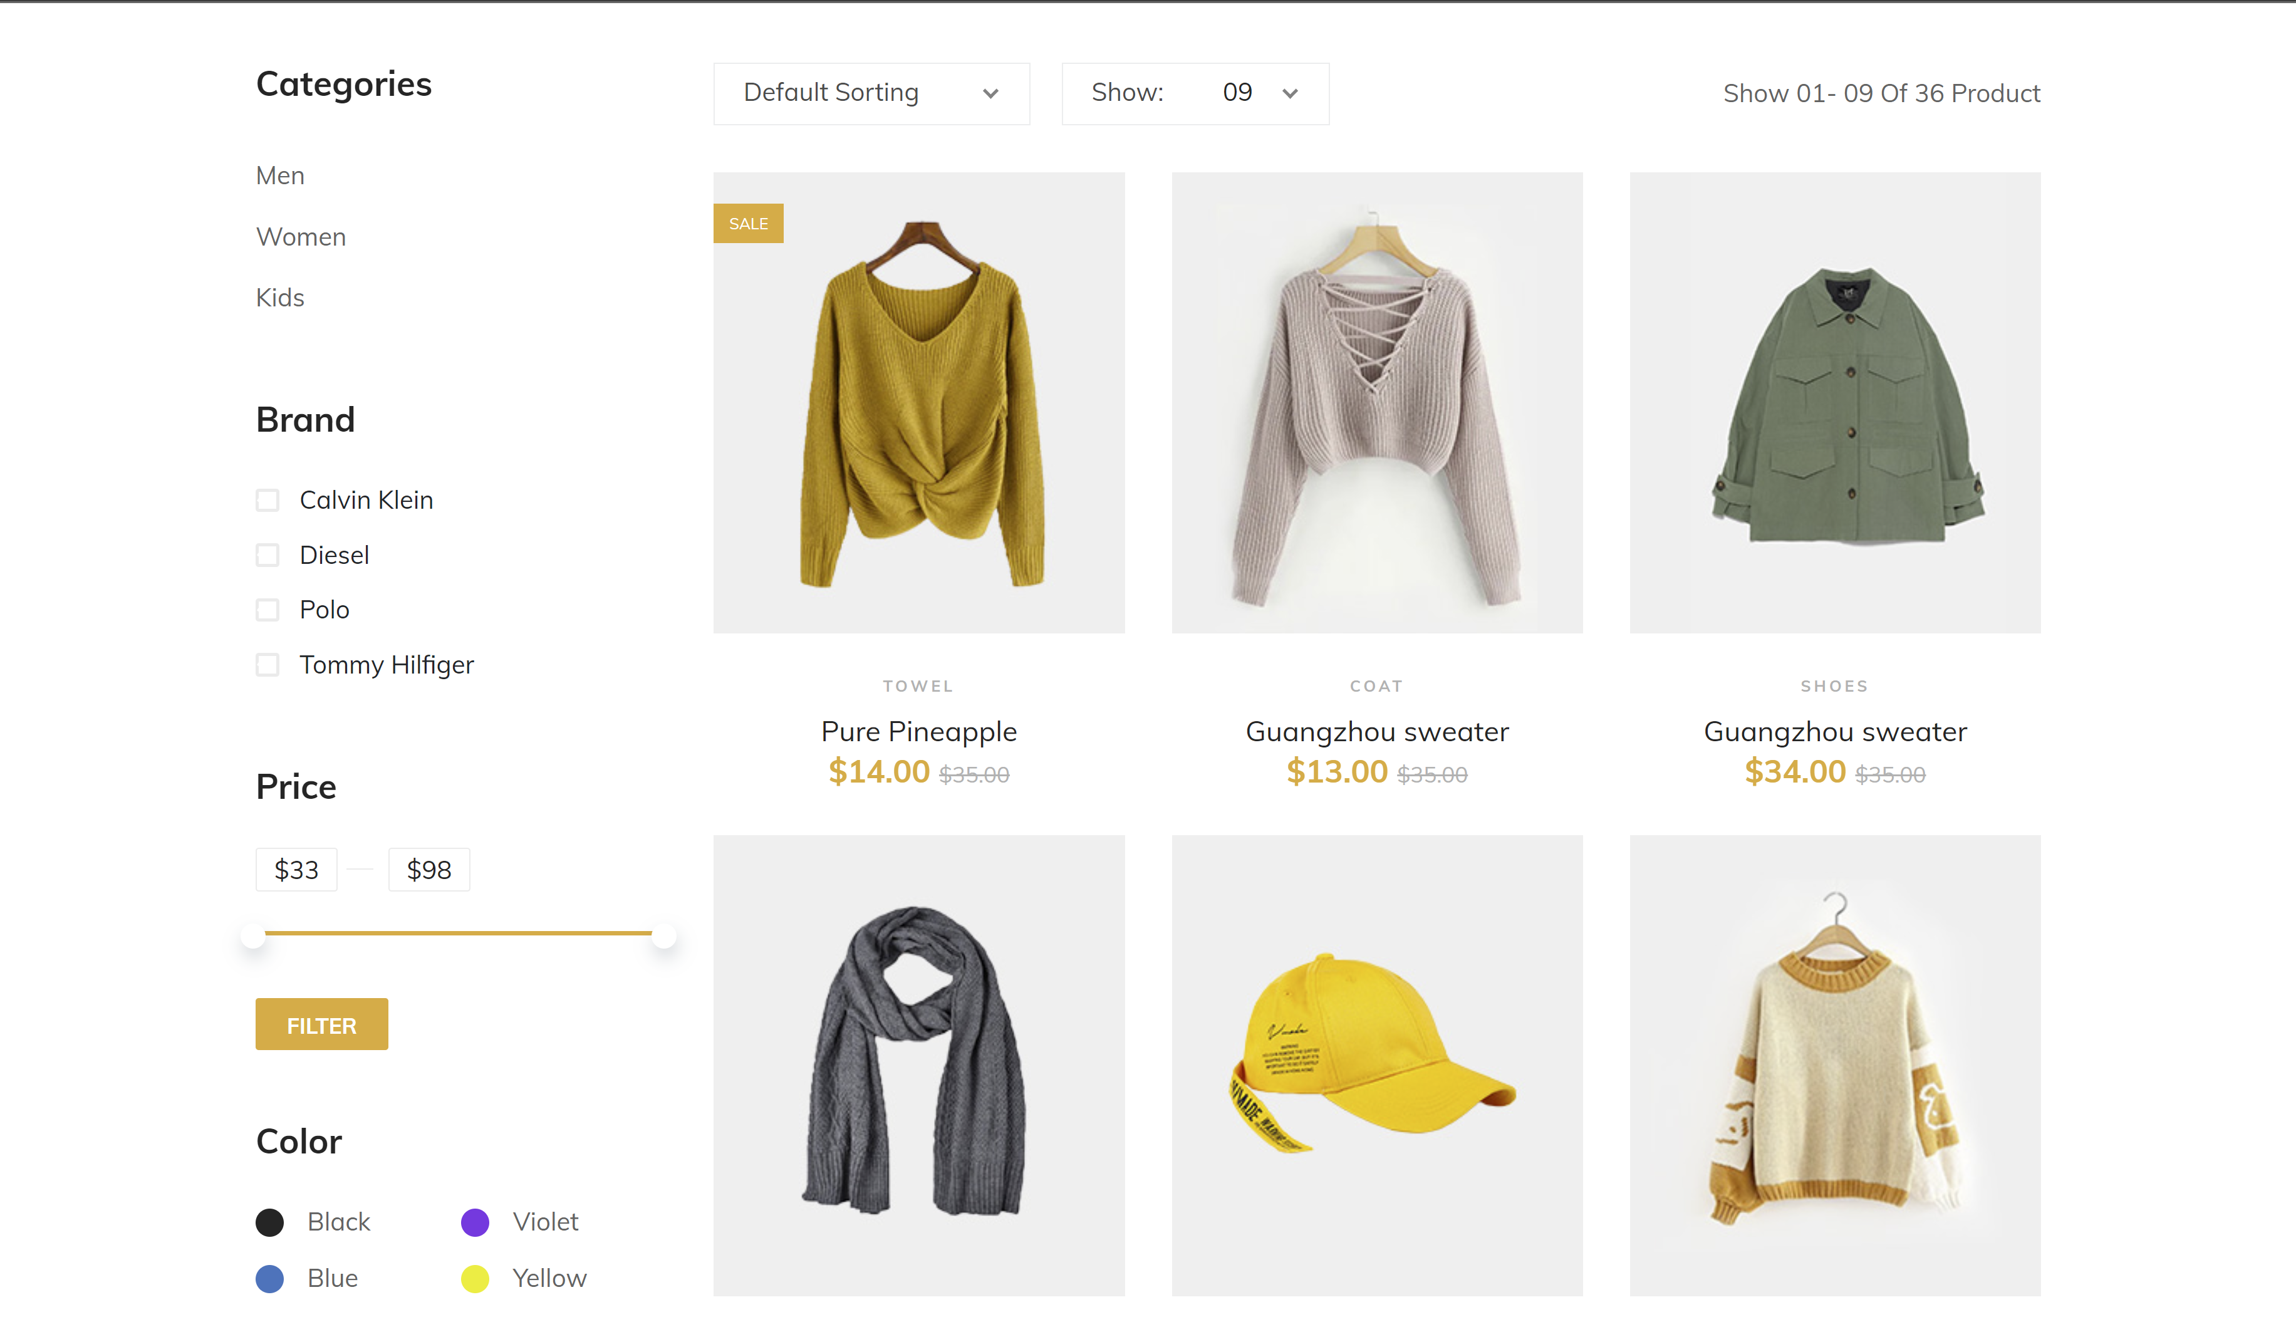

Figure 11: Fashi Shop Page

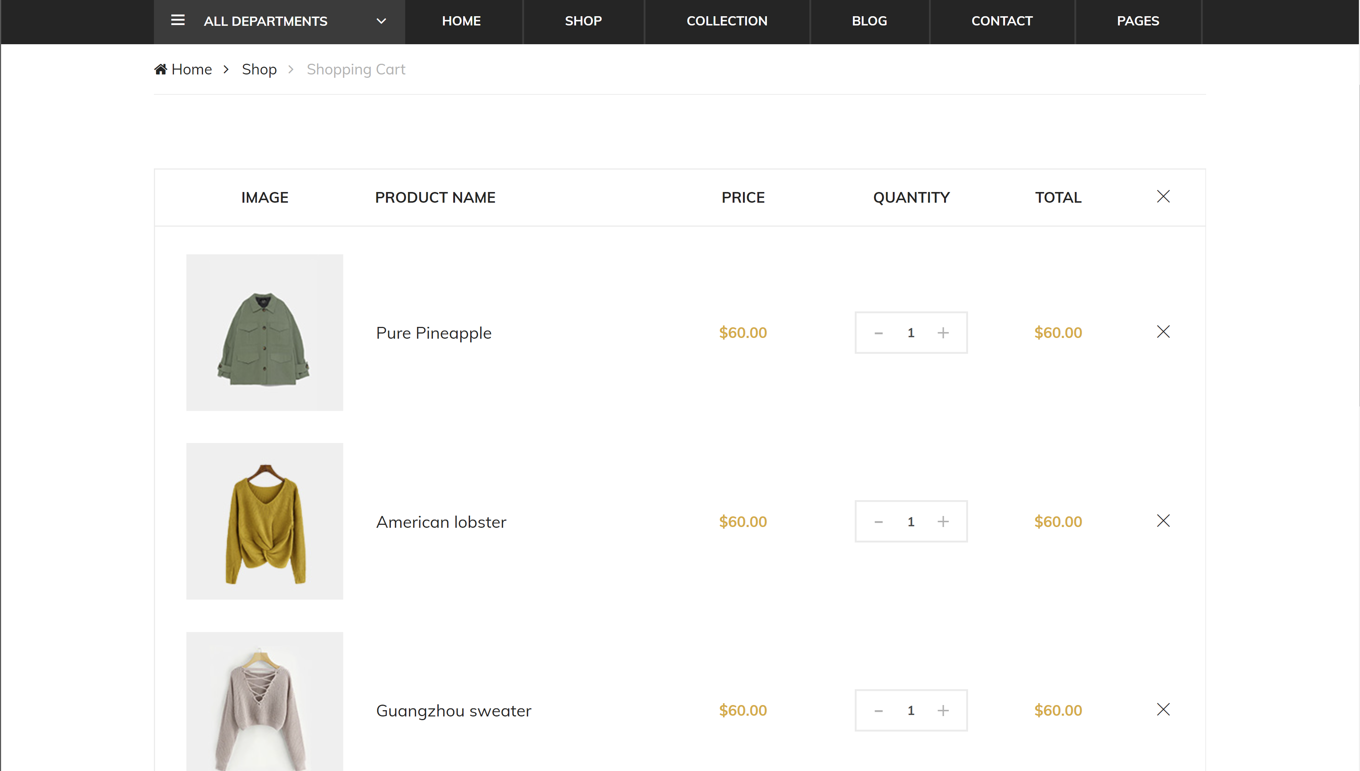

Figure 12: Fashi Shopping Cart Page

Features:

* Clean and minimal design
* Multi-page template
* Cross-browser compatibility
* Fully responsive
* Hero header
* Slider on the header
* Drop-down menu
* Search option
* Call to action button
* Hover effect
* Content slider
* Countdown timer
* Blog section
* Footer navigations
* CSS3 preloader
* Product grid
* Google maps
* Comment form UI
* Newsletter subscription form
* Contact form
* Shopping cart
* Accordions
* Two authentication pages

Number 19 - [Aviato E-commerce Template - Themefisher](https://themefisher.com/products/aviato-e-commerce-template/)

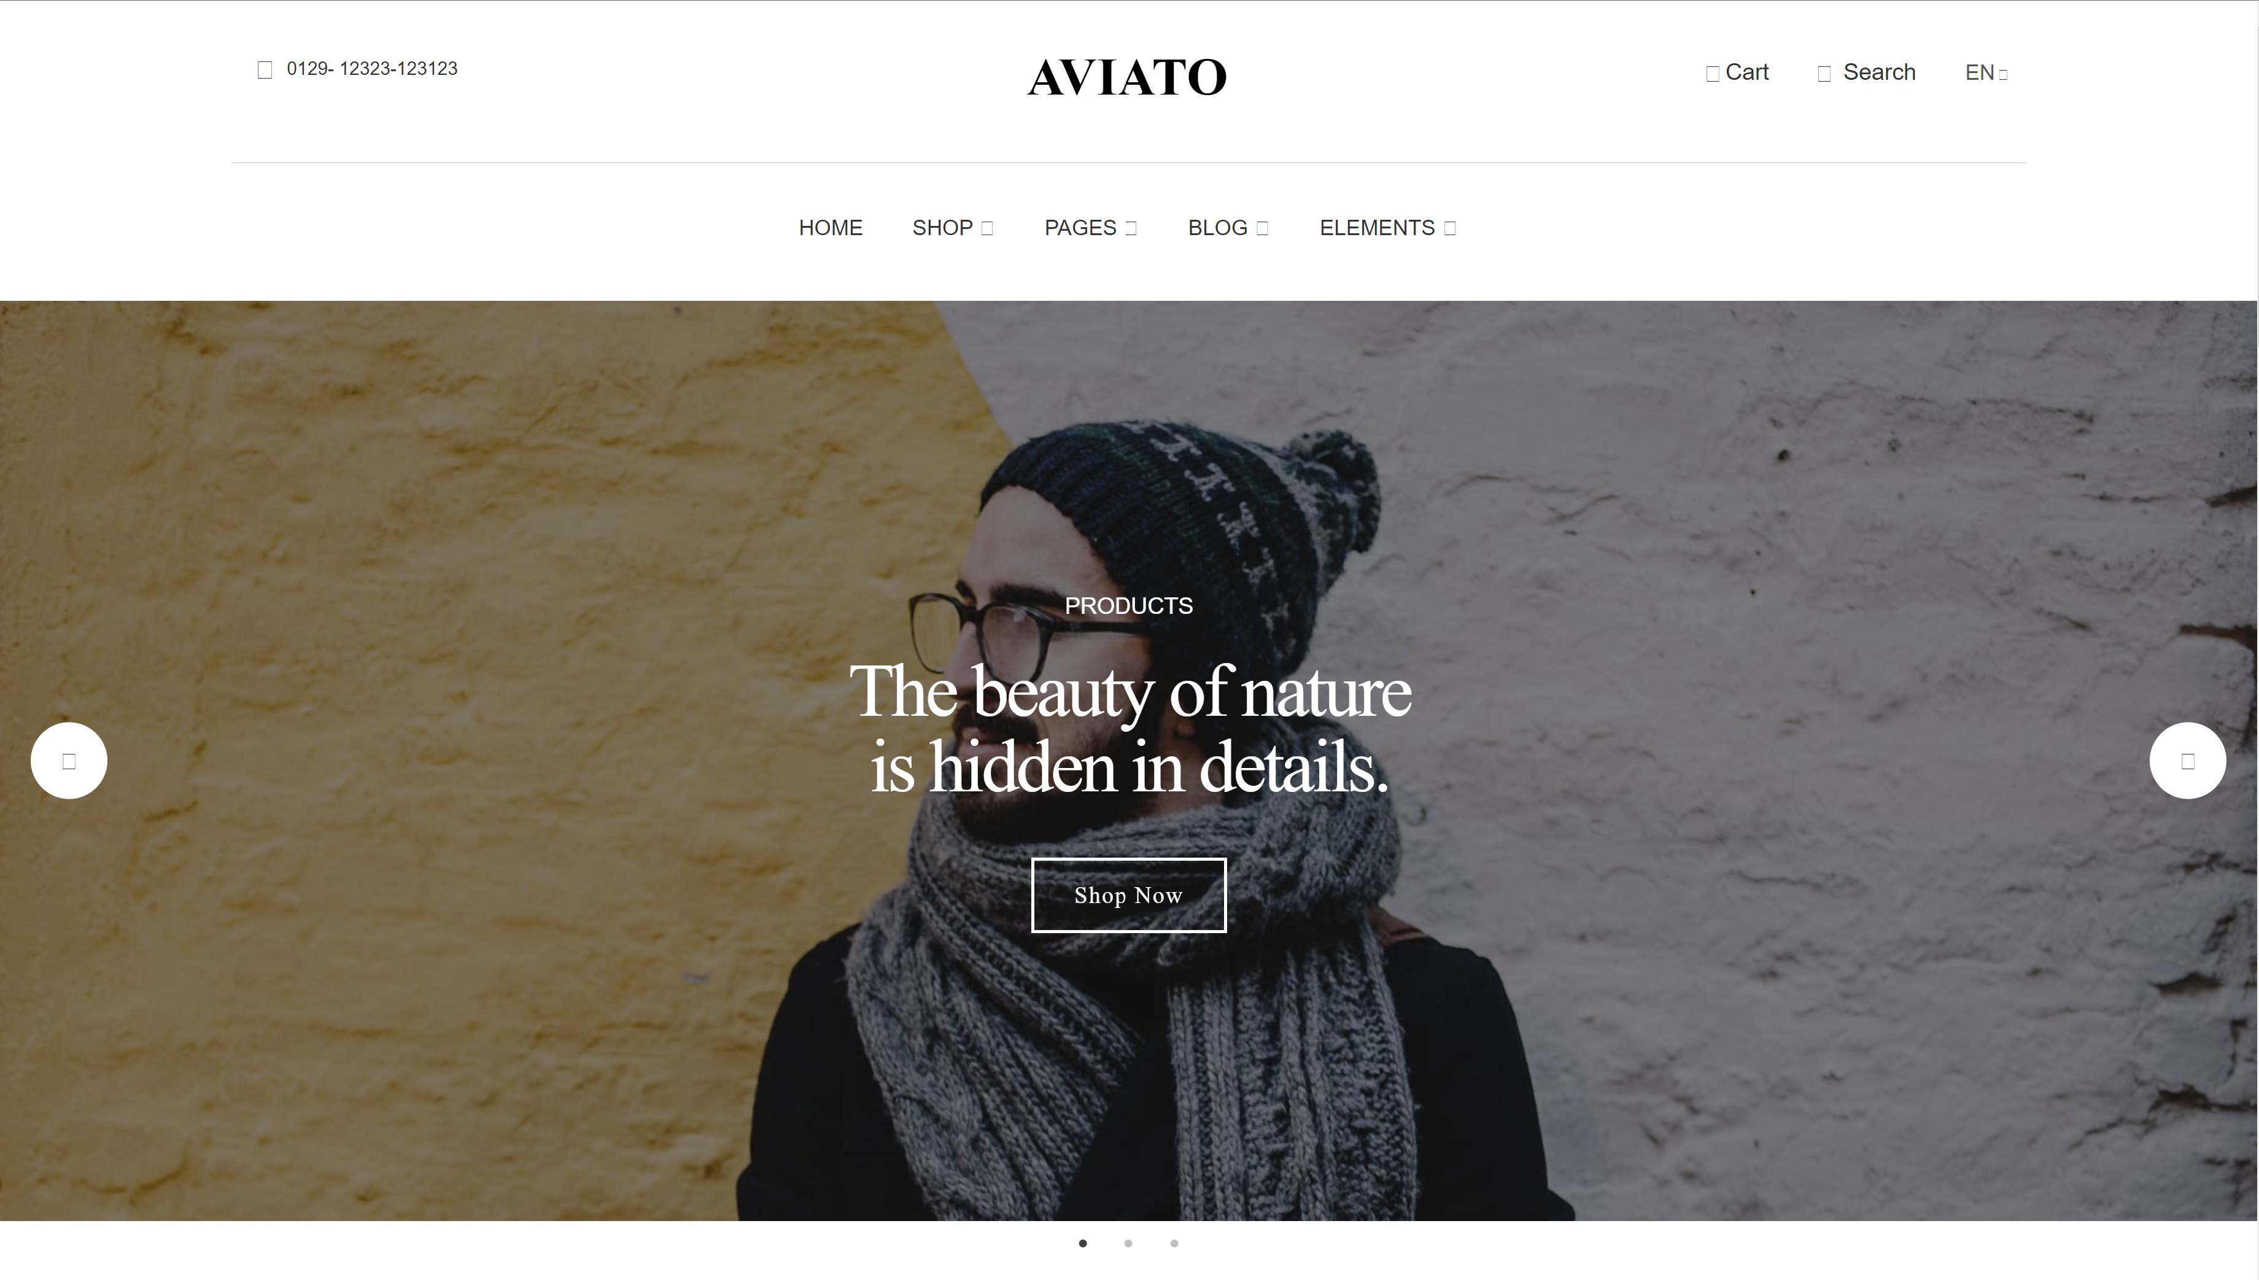

Figure 13: Aviato Home Page

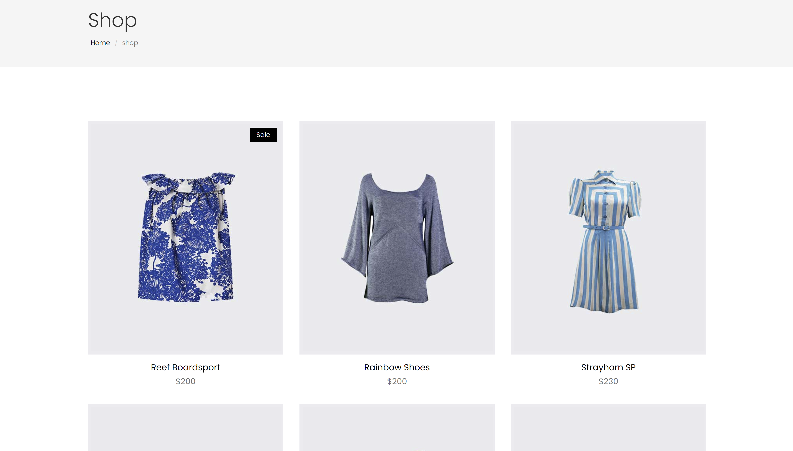

Figure 14: Aviato Shopping Page

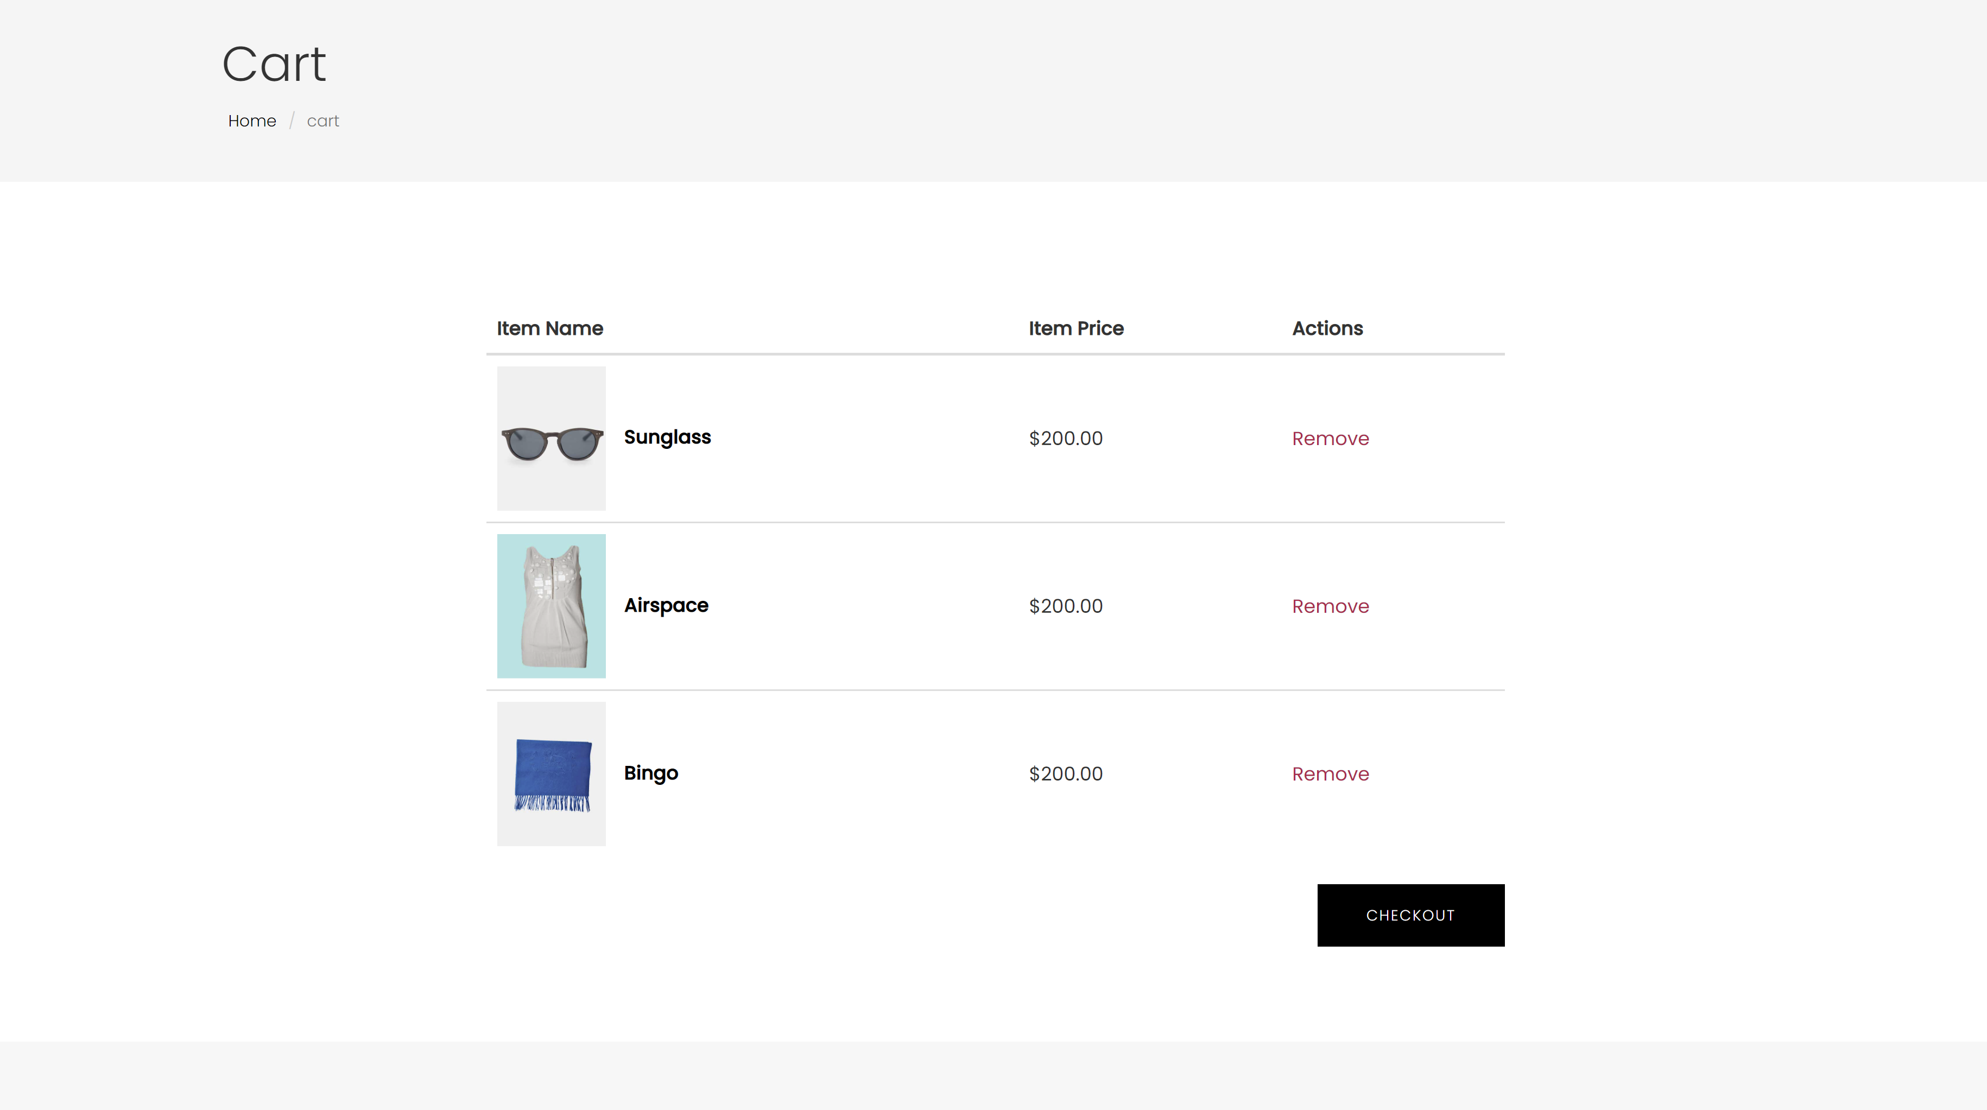

Figure 15: Aviato Cart Page

Features:

* Cool and minimal design
* 30+ pages
* Fully responsive
* Hero header
* Slider on the header
* Drop-down menu
* Search option
* Product grid
* Blog section
* User account page
* Shopping cart
* Sign up and log in authentication